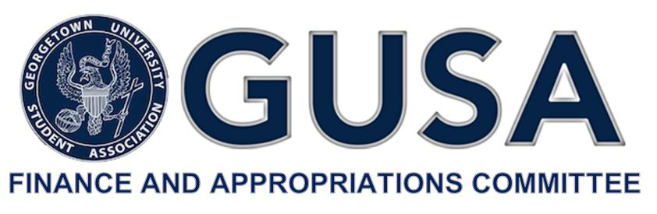

Dear Applicant,

Thank you for your interest in applying for funding from the Student Activities Fee for FY20. The Committee is excited to spend time getting to know the unique ways that your organization contributes to the vitality of student life at Georgetown.

The following application, in conjunction with your presentation at the Budget Summit, is designed to give the Committee a complete picture as to the past, present, and projected impact your organization makes on student life. The application is organized into five parts, A through E, explained in detail below. Your assigned liaison will guide you through the application and will be available to answer questions throughout the application process. Additionally, the Committee will hold two informational sessions to provide a comprehensive overview of the process. The Committee will also hold office hours during the duration of the application period. Please refer to the email announcement of this application for specific dates and locations.

As you complete your application, please keep in mind that the Committee will likely receive far more requests than the Student Activities Fee can accommodate. This fact necessitates the Committee make near-impossible judgements regarding the positive impact that each dollar allocated can make to enhance student life. Thus, the Committee carefully assesses each application based on the organization’s demonstrated impact on the Georgetown community.

The Committee thanks you for the time and effort spent compiling your financial data and answering our questions. We look forward to working with you throughout this process and hearing from you at the upcoming Budget Summit.

Best Regards,

Hayley Grande

Chair, GUSA Finance and Appropriations Committee

GUSA Finance & Appropriations Committee

**FY20 Budget Summit**

Student Activity Fee Funding Application

(APPLICATION A - Advisory Boards, GPB, the GUSA Executive-Elect and the Lecture Fund)

Please email this application and accompanying materials to gusafinapp@georgetown.edu by **Sunday, February 10, 2019 at 11:59 pm.**

**PART A.**

Name of Organization: Norman and Aleida for Georgetown

Mission of Organization: We are building a GUSA that is by Georgetown and for Georgetown,

on values of transparency, reform, accessibility, and progress. We believe student government can empower students on this campus and break down barriers to progress — helping Hoyas achieve according to their own definition – we want a GUSA that works for us all.

Total Amount of Funding Requested: $26,760.00

**PART B.**

Please complete the Financial Information (A) FY20 excel document and attach it to your email submission.

**PART C.**

Please attach a copy of the budgeting guidelines used by your organization for any and all purposes, and answer the following questions in this document:

1. In short, what is your organization’s budgeting or funding process? (Please provide a brief summary; specifics should be included in the budgeting guidelines you will attach).
2. If your full funding request is not met, what is the process in place to determine cuts to group budgets or programming?
3. Is there any other information you would like the Committee to consider regarding your organization’s budgeting process and guidelines?

**PART D.**

Please answer the following questions individually in this document:

1. How did your organization affect student life? Can this be measured?

As an organization GUSA advocates for the Georgetown student body with the University’s administration, the Georgetown neighborhood, and the DC community. It holds both itself and the administration accountable to students. As the advocate of the student body, GUSA prioritizes student concerns and initiatives, rallying the student body and the broader Georgetown community around them. T.R.A.P. is crucial to GUSA being able to fulfill its mission—GUSA must be representative and inclusive of all identities and communities that make up our student body.

1. How many clubs/groups compose your organization? Please list them, noting especially any clubs/groups added (or planned to be added) within FY19.

GUSA Executive, GUSA Senate, GUSA Fund, Student Advocacy Office, DC and Federal Relations Committee, What’s A Hoya

1. What were significant challenges for your organization over the past year? What were significant successes for your organization over the past year?

Significant challenges included trust of the GUSA Executive with the Georgetown student body. Successes included further development of relationships with administration and innovative collaboration to support student race & culture and student engagement.

1. Do you have any budget concerns for the next 5-10 years?

N/A

1. What level of financial risk does your organization incur? What type of event or circumstance prompts the use of your reserve account?

N/A

1. How could the Budget Summit process be improved this year? How could relations with GUSA be improved?

N/A

1. If you are requesting more funding for FY20 than FY19, please explain why.

Last year the GUSA Budget was cut to $13,995. We have noticed that although the executive discretionary fund and senate sunny day fund are lower than years past, the two branches have still been able to function accordingly. We recognize the money the finance and appropriations committee has is finite and every dollar allocated to GUSA could be used towards another organization. However, we feel it is extremely important that menstrual products are funded to make equitable access to menstrual products by all people on campus a reality. Additionally, we’ll be requesting money to retroactively fund the putting on of “The Haze” a play by Heather Marlowe, a sexual assault activists and play writer.

**PART E.**

Please ensure your organization continues to comply with the 2010 6-Point Reform Plan by **commenting in the affirmative and detailing** how your group is compliant for each of the 6 points individually.

1. The total balance of any advisory board’s reserve account shall not be excessive (as deemed by the Office of the Vice President for Student Affairs), and boards with surplus funds should provide a plan for their reserves.

Aleida and I affirm this point.

1. An appeals process shall be implemented and publicized, where such processes do not already exist, for clubs that are denied full funding for an activity or annual budget under its advisory board.

Aleida and I affirm this point.

1. Clubs shall have the option of requesting a lump sum, annual budget with an opportunity to reapply for additional funding from its advisory board.

Aleida and I affirm this point.

1. All meetings and recorded minutes of all meetings of an advisory board shall be open to the public, including any and all votes, and that all records are posted online in a timely fashion.

Aleida and I affirm this point.

1. Members of the advisory board are, in some way, directly accountable to their constituents or to the student body in general, such as having GUSA Senate confirmation or being elected by the leaders of the clubs they represent.*

Aleida and I affirm this point.

1. Clubs have reasonable control over all funds that they fundraise outside of the normal allocations process.

Aleida and I affirm this point.

*The committee is aware that the structure of boards has changed in the past eight years; please note ‘such as’ merely indicates examples of how accountability is manifested and focus on the spirit of the Point.

**CERTIFICATION:**

By signing below, I hereby certify that the information enclosed is accurate to the best of my knowledge.

**Funding Request Form Submitted By:**

Norman and Aleida for Georgetown

**Name of Group Student Chair:**

Norman Francis and Aleida Olvera

**Signature of Group Student Chair (type your name):**

Norman Francis and Aleida Olvera

**Name of Group Advisor:**

Aysha Dos

**Signature of Group Advisor (type your name):**

**Date:**

1/30/2019

**Contact Email:**

Naf49@georgetown.edu

**Contact Phone Number:**

(240) 810-2780